

**COLEGIO DEL SAGRADO CORAZÓN**

**PREPARATION WORKSHOP FOR THE THIRD TERM FINAL EXAM**

**Subject : English Teacher: Ali Chadid Yaber**

**Name: _______________________________________________ Grade: Second ( )**

**Weekly routine. Complete the following sentences:**

1. What time do you do your homework? ______________________
2. What time do you brush your teeth?_________________________
3. _____________________________? I go to bed at 12:00 o’clock

**In, on, at. Choose the correct answer.**

1. **Carlos sleeps…**
2. at night
3. in the night
4. at the night
5. **They teach math…**
6. at Tuesday
7. in Tuesday
8. on Tuesday
9. **I get up…**
10. in the five
11. at five
12. on five
13. I do my homework…
14. on the afternoon
15. in the afternoon
16. at the afternoon

**There is/isn’t – There are/aren’t. Complete the following sentences.**

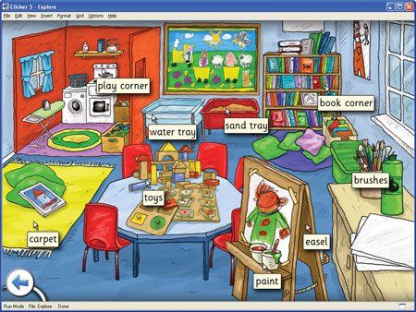

1. There is a ____________
2. There are some _____________
3. _______________ a water tray
4. _______________ some cars
5. _______________ Some books

**WEEKLY routine. Read the text and write “true” or “false”.**

Ana wakes up early every morning. After brushing her teeth, she eats breakfast and goes to school. At school, Ana studies hard and talks with her friends. When she gets home, Ana helps her mom in the kitchen and then plays with her dog. After dinner, she watches TV, takes a shower, and goes to bed.

13- Ana doesn’t wake up late ( )

14- Ana helps her mom in the kitchen ( )

15- She plays with her friends after school ( )

16- After dinner, she goes to school ( )

**Weekly routine. Complete the following sentences.**

I am ___________. **(17)** I get up__________________ **(18)** I__________ a shower__________. **(19)** I _____ to school_______________ and **(20)** I ______________ dinner___________.